Lab-3

Supplier database

**Code:**

**create database supplier;**

**use supplier;**

**create table Suppliers(**

**sid int primary key,**

**sname varchar(20) not null,**

**address varchar(20)not null);**

**create table Parts(**

**pid int primary key,**

**pname varchar(20) not null,**

**color varchar(10) not null);**

**create table Catalog(**

**sid int,**

**pid int,**

**cost real not null,**

**primary key(sid,pid),**

**foreign key(sid) references Suppliers(sid),**

**foreign key(pid) references Parts(pid));**

**desc suppliers;**

**desc parts;**

**desc catalog;**

**insert into Suppliers**

**values**

**(10001,"Acme Widget","Bangalore"),**

**(10002,"Johns","Kolkata"),**

**(10003,"Vimal","Mumbai"),**

**(10004,"Reliance","Delhi");**

**select * from suppliers;**

**insert into Parts**

**values**

**(20001,"Book","Red"),**

**(20002,"Pen","Red"),**

**(20003,"Pencil","Green"),**

**(20004,"Mobile","Green"),**

**(20005,"Charger","Black");**

**select * from parts;**

**insert into Catalog**

**values**

**(10001,20001,10),**

**(10001,20002,10),**

**(10001,20003,30),**

**(10001,20004,10),**

**(10001,20005,10),**

**(10002,20001,10),**

**(10002,20002,20),**

**(10003,20003,30),**

**(10004,20003,40);**

**select * from catalog;**

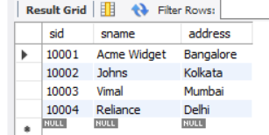 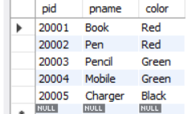 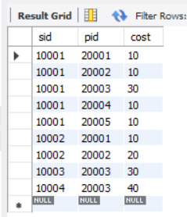

Queries and screenshot:

**1**. select pname,s.sname from Parts p,Catalog c,Suppliers s

where

c.sid in (select distinct sid from Suppliers) and

p.pid=c.pid and

c.sid=s.sid;

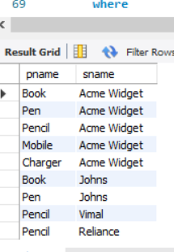

**2**.-- Find the snames of suppliers who supply every part.

select s.sname from Catalog c,Suppliers s

where

c.sid=s.sid

group by c.sid

having count(c.sid)=(select count(*) from Parts);

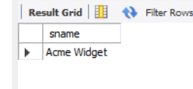

**3.**-- Find the snames of suppliers who supply every red part.

select s.sname,count(*) from Catalog c,Suppliers s,Parts p

where

c.sid=s.sid and

p.pid=c.pid and

c.pid in (

select c.pid from Catalog c,Parts p where c.pid=p.pid and

p.color="red"

group by c.pid

)

group by s.sid

having count(*)=(

select count(*) from Parts where color="red" group by color

);

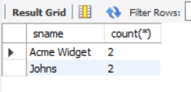

**4**.-- Find the pnames of parts supplied by Acme Widget Suppliers and by no one else.

select p.pname from Parts p,Suppliers s,Catalog c

where

s.sid=c.sid and

p.pid=c.pid and

s.sname="Acme Widget" and

c.pid not in (select c.pid from Catalog c,Suppliers s where s.sname <> "Acme Widget"and c.sid=s.sid)

group by c.pid;

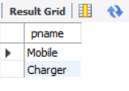

**5.**-- Find the sids of suppliers who charge more for some part than the average cost of that

-- part (averaged over all the suppliers who supply that part).

select sid from Catalog c1

where cost>(select avg(cost) from Catalog

where c1.pid=pid

group by pid)

;

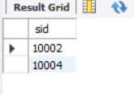

**6**-- For each part, find the sname of the supplier who charges the most for that part.

select sid,pid from Catalog c1

where

cost=(select max(cost) from Catalog

where c1.pid=pid

group by pid)

;

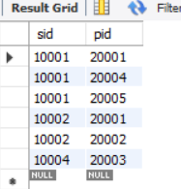

Lab-4

Student faculty database

**Code:**

create database studentfacdb;

use studentfacdb;

create table STUDENT(

snum int,

sname varchar(60),

major varchar(50),

lvl varchar(50),

age int,

primary key(snum)

);

create table CLASS(

cname varchar(60),

meetsat timestamp,

room varchar(60),

fid int,

primary key (cname)

);

create table enrolled(

snum int,

cname varchar(60),

primary key(snum,cname),

foreign key(snum) references STUDENT(snum)

on update cascade on delete cascade,

foreign key(cname) references CLASS(cname)

on update cascade on delete cascade

);

create table FACULTY(

fid int,

fname varchar(60),

deptid int,

primary key(fid)

);

desc student;

desc class;

desc enrolled;

desc faculty;

insert into STUDENT

values

(1,'Jhon','CS','Sr',19),

( 2,'Smith','CS','Jr',20),

(3,'Jacob','CV','Sr',20),

(4,'Tom','CS','Jr',20),

(5,'Rahul','CS','Jr',20),

(6,'Rita','CS','Sr',21);

insert into CLASS values

('Class1',"12/11/15 10:15:16.00000",'R1',14),

('Class10',"12/11/15 10:15:16.00000",'R128',14),

('Class2',"12/11/15 10:15:20.00000",'R2',12),

('Class3',"12/11/15 10:15:25.00000",'R3',11),

('Class4',"12/11/15 20:15:20.00000",'R4',14),

('Class5',"12/11/15 20:15:20.00000",'R3',15),

('Class6',"12/11/15 13:20:20.00000",'R2',14),

('Class7',"12/11/15 10:10:10.00000",'R3',14);

insert into ENROLLED

values

(1,'Class1'),

(2,'Class1'),

(3,'Class3'),

(4,'Class3'),

(5,'Class4'),

(1,'Class5'),

(2,'Class5'),

(3,'Class5'),

(4,'Class5'),

(5,'Class5');

insert into FACULTY

values

(11,'Harish',1000),

(12,'MV',1000),

(13,'Mira',1001),

(14,'Shiva',1002),

(15,'Nupur',1000);

select * from STUDENT;

select * from CLASS;

select * from ENROLLED;

select * from FACULTY;

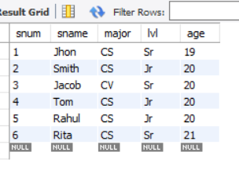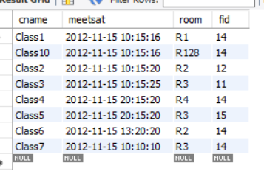

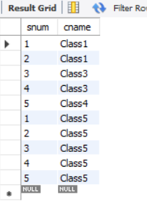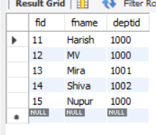

Queries and screenshot:

**1**. select s.sname from STUDENT s, CLASS c, FACULTY f,ENROLLED e

where

s.snum=e.snum and

s.lvl='Jr' and

e.cname=c.cname and

f.fid=c.fid and

f.fname="Harish";

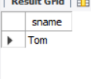

**2.** select c.cname from class c

where c.room = 'R128'or

c.cname in (select e.cname from enrolled e group by e.cname having count(e.snum)>=5);

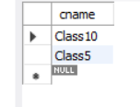

**3**. select distinct s.sname from student s

where

s.snum in

(select e1.snum from enrolled e1, enrolled e2, class c1, class c2

where e1.snum = e2.snum and e1.cname <> e2.cname and e1.cname = c1.cname

and e2.cname = c2.cname and c1.meetsat = c2.meetsat);

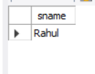

**4.** select distinct f.fname from faculty f

where

not exists

(select room from class

where

room not in (select c.room from class c where c.fid=f.fid));

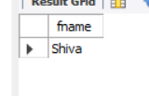

**5.** select distinct f.fname from faculty f

where 5>

(select COUNT(e.snum) from Class c, enrolled e

where c.cname = e.cname and c.fid = f.fid);

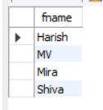

**6.** select distinct s.sname from student s

where

s.snum not in(select e.snum from enrolled e);

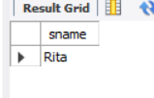

**7.** select S.age,S.lvl,count(*) from student S

group by S.age,S.lvl

having S.lvl in (select s1.lvl from Student s1

where s1.age=S.age

group by s1.age,s1.lvl

having count(*)>=all

(Select count(*) from student s2

where s1.age=s2.age group by s2.lvl,s2.age)

);

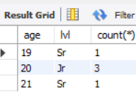

Lab-5

Airline database

**Code:**

CREATE DATABASE airlinedb;

USE airlinedb;

CREATE TABLE FLIGHTS

(

flno int,

ffrom varchar(30),

tto varchar(30),

distance int,

departs timestamp,

arrives timestamp,

price int,

primary key(flno)

);

CREATE TABLE AIRCRAFT

(

aid int,

aname varchar(30),

cruisingrange int,

primary key(aid)

);

CREATE TABLE EMPLOYEES

(

eid int,

ename varchar(30),

salary int,

primary key(eid)

);

CREATE TABLE CERTIFIED

(

eid int,

aid int,

FOREIGN KEY(aid) REFERENCES AIRCRAFT(aid),

FOREIGN KEY(eid) REFERENCES EMPLOYEES(eid)

);

INSERT INTO FLIGHTS

VALUES (101,"Bangalore","Delhi",2500,'2005-05-13:07:15:31','2005-05-13:07:15:31',5000),(102,"Bangalore","Lucknow",3000,'2005-05-13:07:15:31','2005-05-13:11:15:31',6000),

(103,"Lucknow","Delhi",500,'2005-05-13:12:15:31','2005-05-13:17:15:31.000000',3000),(107,"Bangalore","Frankfurt",8000,'2005-05-13:07:15:31','2005-05-13:22:15:31',60000),

(104,"Bangalore","Frankfurt",8500,'2005-05-13:07:15:31','2005-05-13:23:15:31',75000),(105,"Kolkata","Delhi",3400,'2005-05-13:07:15:31','2005-05-13:09:15:31',7000);

SELECT * FROM FLIGHTS;

INSERT INTO AIRCRAFT VALUES (101,"747",3000),(102,"Boeing",900),(103,"647",800),(104,"Dreamliner",10000),

(105,"Boeing",3500),(106,"707",1500),(107,"Dream",120000);

SELECT * FROM AIRCRAFT;

INSERT INTO EMPLOYEES

VALUES (701,"A",50000),(702,"B",100000),(703,"C",150000),(704,"D",90000),

(705,"E",40000),(706,"F",60000),(707,"G",90000);

SELECT * FROM EMPLOYEES;

INSERT INTO CERTIFIED

VALUES (701,101),(701,102),(701,106),(701,105),(702,104),(703,104),(704,104),(702,107),

(703,107),(704,107),(702,101),(703,105),(704,105),(705,103);

SELECT * FROM CERTIFiED;

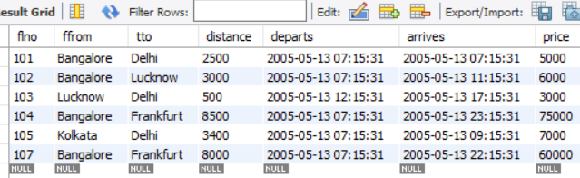

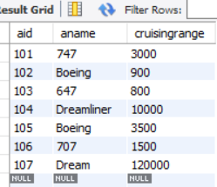 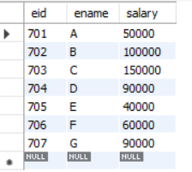

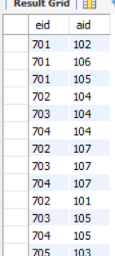

**Lab 5 Queries**

Queries and screenshot:

1. Find the names of aircraft such that all pilots certified to operate them have salaries more than Rs.80,000.
2. For each pilot who is certified for more than three aircrafts, find the eid and the maximum cruisingrange of the aircraft for which she or he is certified.
3. Find the names of pilots whose salary is less than the price of the cheapest route from Bengaluru to Frankfurt.
4. For all aircraft with cruisingrange over 1000 Kms, find the name of the aircraft and the average salary of all pilots certified for this aircraft.
5. Find the names of pilots certified for some Boeing aircraft.
6. Find the aids of all aircraft that can be used on routes from Bengaluru to New Delhi.
7. A customer wants to travel from Bangalore to Delhi with no more than two changes of flight. List the choice of departure times from Bangalore if the customer wants to arrive in Delhi by 6 p.m.
8. Print the name and salary of every non-pilot whose salary is more than the average salary for pilots

**1.** SELECT distinct a.aname

FROM AIRCRAFT a,EMPLOYEES e,CERTIFIED c

WHERE a.aid=c.aid and e.eid=c.eid and e.salary>80000;

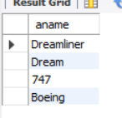

**2.**  SELECT e.eid,e.ename,max(a. cruisingrange)

FROM EMPLOYEES e,CERTIFIED c,AIRCRAFT a

WHERE e.eid=c.eid and a.aid=c.aid

group by e.ename

having count(c.aid)>3;



**3**. SELECT e.ename

FROM EMPLOYEES e

WHERE salary < (select min(price)

from FLIGHTS

where ffrom="Bangalore" and tto="Frankfurt");

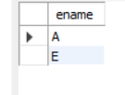

**4.** SELECT a.aname,a.cruisingrange,avg(e.salary)

FROM AIRCRAFT a,EMPLOYEES e,CERTIFIED c

WHERE c.eid=e.eid and c.aid=a.aid

group by a.aname

having a.cruisingrange > 1000;

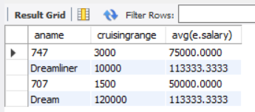

**5.** SELECT distinct e.ename

FROM EMPLOYEES e,CERTIFIED c,AIRCRAFT a

WHERE e.eid=c.eid and a.aid=c.aid and aname like "Boeing";

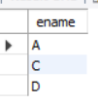

**6.** SELECT a.aid

FROM AIRCRAFT a

WHERE a. cruisingrange >= (select distance

from FLIGHTS

where ffrom="Bangalore" and tto="Delhi");

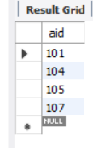

**7.** select departs

from flights f

where tto="Delhi" and arrives<="18:00:00" and f.ffrom="Bangalore"

union

(select departs

from flights

where ffrom="Bangalore" and tto in(select ffrom

from flights

where flno in(select flno

from flights f

where f.tto="Delhi" and f.ffrom in(select distinct(f.tto)

from flights f

where f.ffrom="Bangalore")

and arrives<="18:00:00")));



**8.**

SELECT E.ename, E.salary

FROM EMPLOYEES E

WHERE E.eid NOT IN ( SELECT DISTINCT C.eid

FROM CERTIFIED C )

AND E.salary >( SELECT AVG (E1.salary)

FROM EMPLOYEES E1

WHERE E1.eid IN

( SELECT DISTINCT C1.eid

FROM CERTIFIED C1 ) );



**Code:-** Lab-1

Insurance database

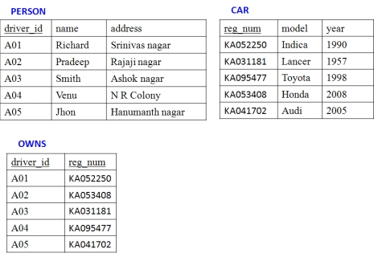

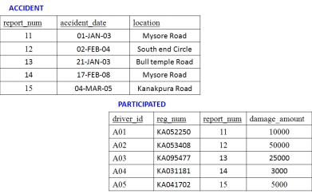

**Lab 1 Queries**

**1. Update the appropriate table for the following details**

**Mr. Smith meet with an accident when he travelled in “Audi (KA05MC001)” car on 1 st march**

**2019 at “Bull temple road”. Police registered a case with number 16 recorded damage**

**amount with 75000. Mr. Smith has bought the car in the year 2018.**

insert into car values('ka05mc001','audi',2018);

insert into owns values('a03','ka05mc001');

insert into accident values(16,'2019-03-01','Bull Temple Road');

insert into participated values('a03','ka05mc001',16,75000);

select * from person;

select * from car;

select * from owns;

select * from accident;

select * from participated;

**AFTER EXECUTION**

Person: Car:

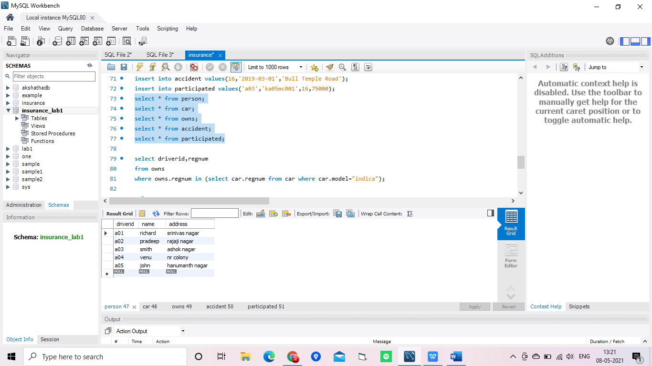 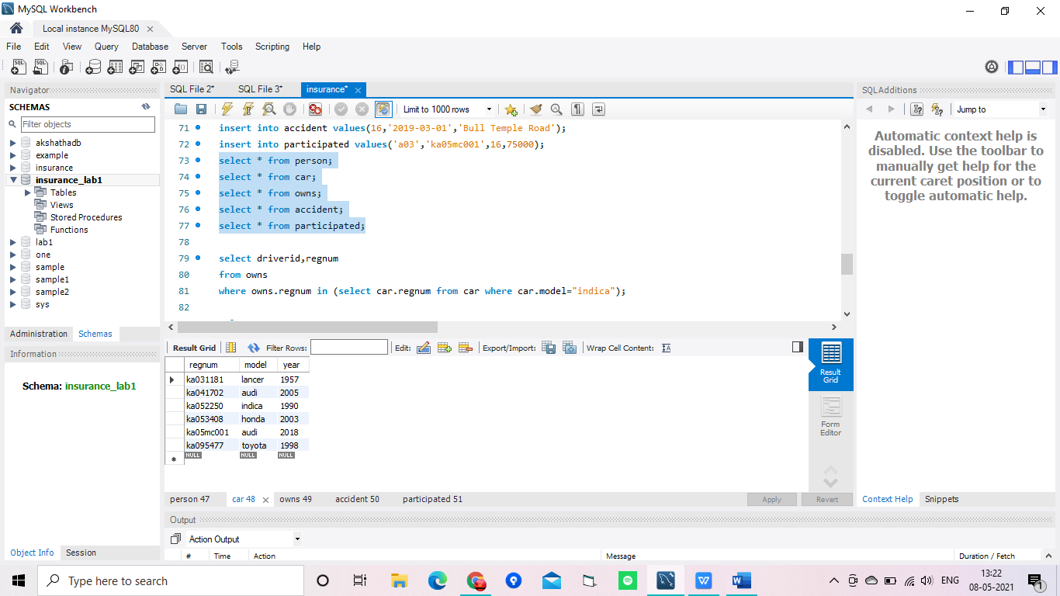

Owns: Accident:

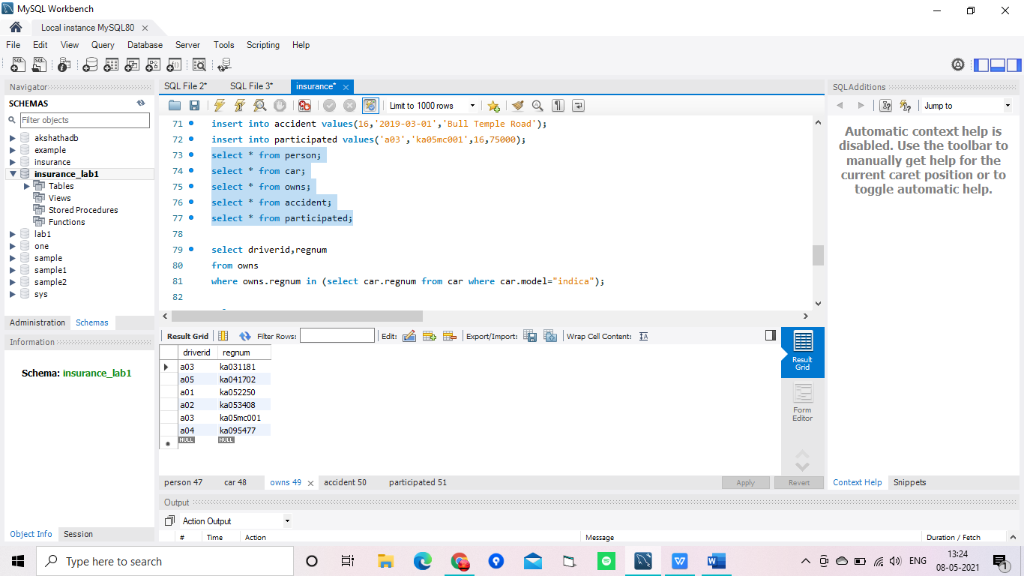 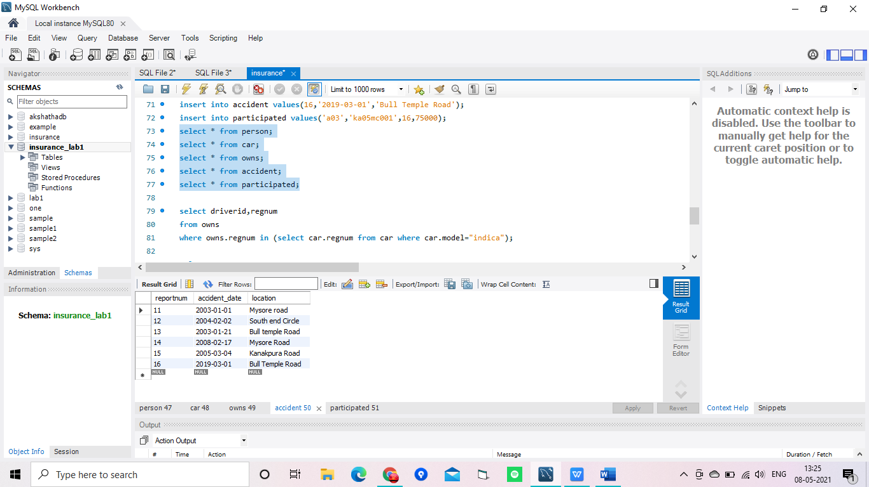

Participated:

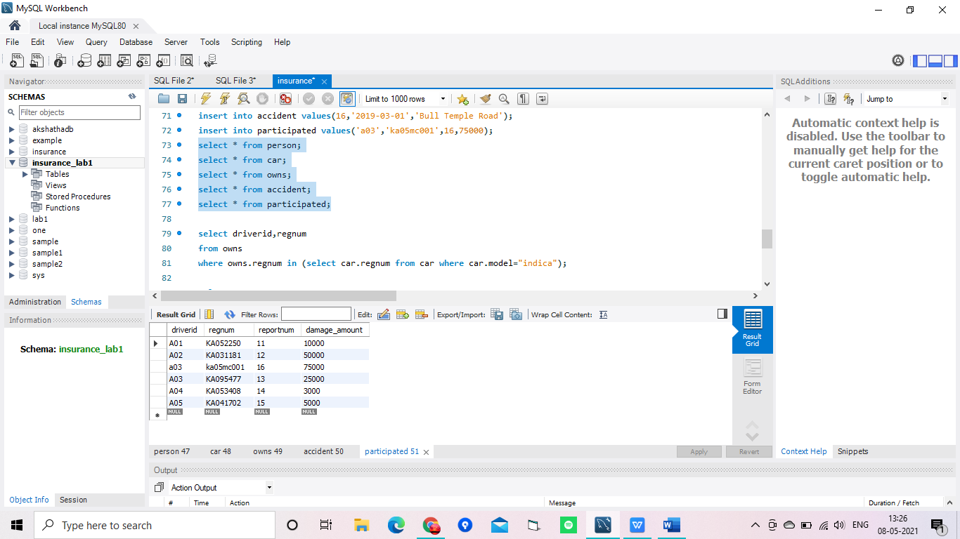

**2. Print driver_id and reg_number of the owner who owns the car “indica”**

select driverid,regnum

from owns

where owns.regnum in (select car.regnum from car where car.model="indica");

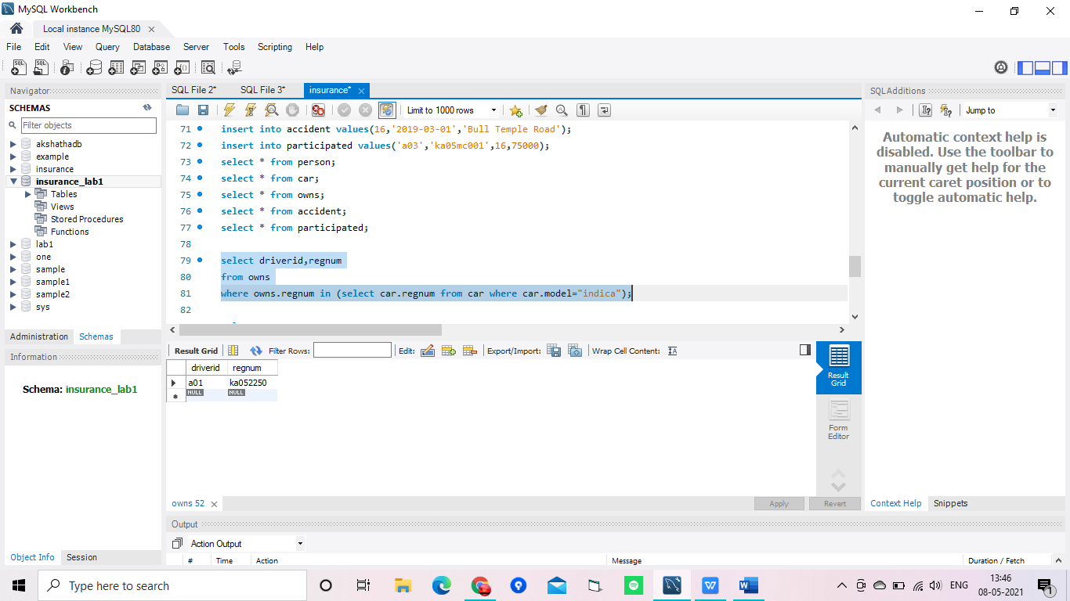

**3. List the reg_nums of the cars which has involved in the accident between the period 2003 to**

**2005**

select regnum

from participated

where reportnum in (select reportnum from accident where accident_date>='2003-01-01' and accident_date<='2005-12-31');

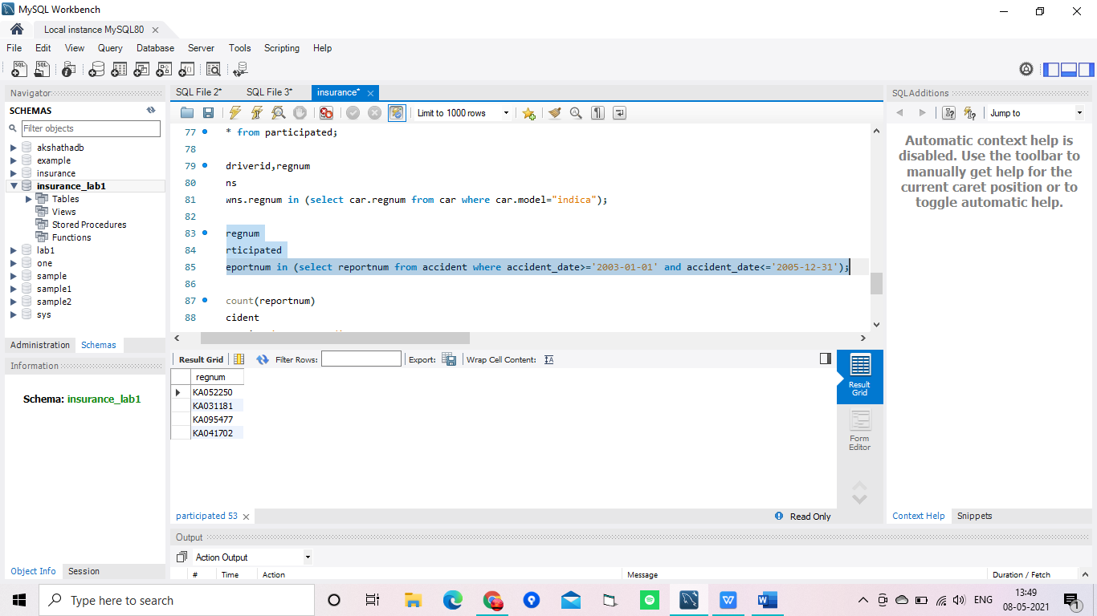

**4. List total no of accident happened in Mysore**

select count(reportnum)

from accident

where location='mysore road';

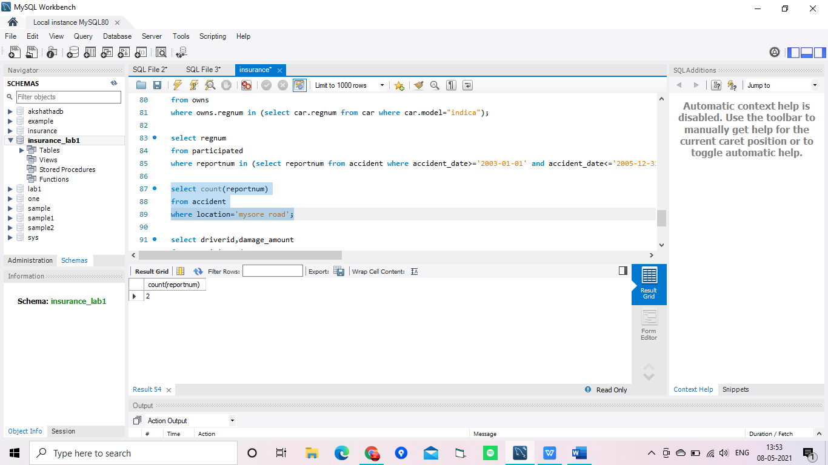

**5. Find the customer whose damage amount is greater than the average damage amount**

select *

from participated

where damage_amount >(select avg(damage_amount)from participated);

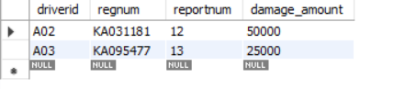

**6. Find the total number of people who owned cars that were involved in accidents in 2008.**

select count(driverid)

from participated

where reportnum in(select reportnum from accident where accident_date>'2008-01-01' and accident_date<'2008-12-31');

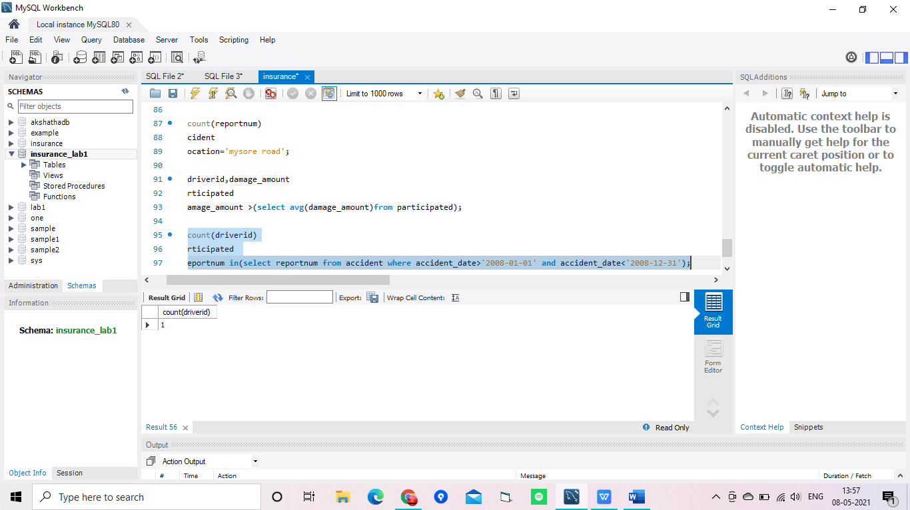

**7. Delete the Audi belonging to “Jhon”.**

ERROR

Lab-2

Banking database

**create database lab3bank;**

**use lab3bank;**

**create table Branch(**

**branchname varchar(20),**

**branchcity varchar(20),**

**assets real,**

**primary key(branchname));**

**create table BankAccount(**

**accnum int,**

**branchname varchar(20),**

**balance real,**

**primary key(accnum),**

**foreign key(branchname) references Branch(branchname));**

**create table BankCustomer(**

**customername varchar(20),**

**customerstreet varchar(20),**

**customercity varchar(20),**

**primary key(customername));**

**create table Depositer(**

**customername varchar(20),**

**accnum int,**

**primary key(customername, accnum),**

**foreign key(customername) references BankCustomer(customername),**

**foreign key(accnum) references BankAccount(accnum));**

**create table Loan(**

**loannum int,**

**branchname varchar(20),**

**amount real,**

**primary key(loannum),**

**foreign key(branchname) references Branch(branchname));**

**desc Branch;**

**desc BankAccount;**

**desc BankCustomer;**

**desc Depositer;**

**desc Loan;**

**insert into Branch values ('SBI_Chamrajpet','Bangalore',50000),('SBI_ResidencyRoad','Bangalore',10000),('SBI_ShivajiRoad','Bombay',20000),**

**('SBI_ParliamentRoad','Delhi',10000),('SBI_Jantarmantar','Delhi',20000);**

**select * from Branch;**

**insert into BankAccount values (1,'SBI_Chamrajpet',2000),(2,'SBI_ResidencyRoad',5000),(3,'SBI_ShivajiRoad',6000),(4,'SBI_ParliamentRoad',9000),**

**(5,'SBI_Jantarmantar',8000),(6,'SBI_ShivajiRoad',4000),(8,'SBI_ResidencyRoad',4000),**

**(9,'SBI_ParliamentRoad',3000),(10,'SBI_ResidencyRoad',5000),(11,'SBI_Jantarmantar',2000);**

**select * from BankAccount;**

**insert into BankCustomer values ('Avinash','Bull Temple Road','Bangalore'),('Dinesh','Bannergatta Road','Bangalore'),('Mohan','NationalCollege_Road','Bangalore'),**

**('Nikil','Akbar Road','Delhi'),('Ravi','Prithviraj Road','Delhi');**

**select * from BankCustomer;**

**insert into Depositer values ('Avinash',1),('Dinesh',2),('Nikil',4),('Ravi',5),('Avinash',8),**

**('Nikil',9),('Dinesh',10),('Nikil',11);**

**select * from Depositer;**

**insert into Loan values (1,'SBI_Chamrajpet',1000),(2,'SBI_ResidencyRoad',2000),(3,'SBI_ShivajiRoad',3000),**

**(4,'SBI_ParliamentRoad',4000),(5,'SBI_Jantarmantar',5000);**

**select * from Loan;**

**Screenshots:-**

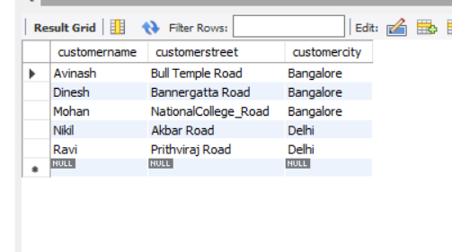

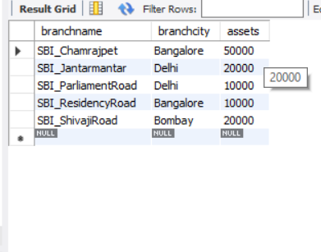

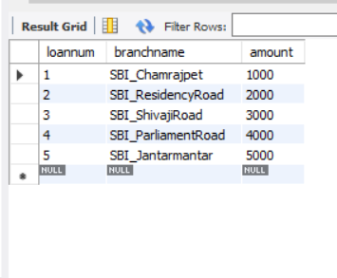

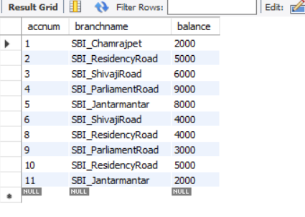

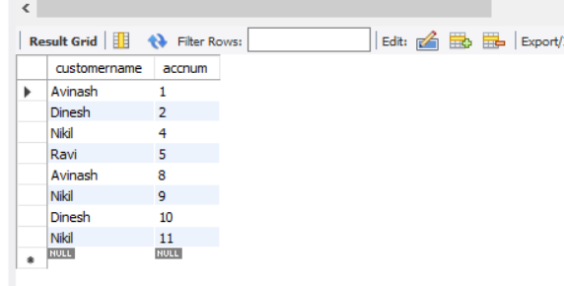

**Query:-**

**1.Find all the customers who have atleast two deposits at the same branch (ex: “SBI_Residency_road”)**

**select depositer.customername**

**from Depositer , BankAccount**

**where BankAccount.accnum = depositer.accnum and BankAccount.branchname = 'SBI_ResidencyRoad'**

**group by depositer.customername having count(*) >= 2;**

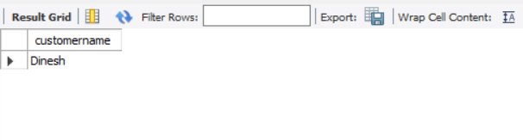

**2. find all the customers who have an account at all the branches located in a specific city (ex: “delhi”)**

**select depositer.customername**

**from Depositer , BankAccount , Branch**

**where depositer.accnum=BankAccount.accnum and Branch.branchname=BankAccount.branchname and branch.branchcity='Delhi'**

**group by Depositer.customername**

**having count(distinct Branch.branchname)=(select count(branchname)**

**from Branch where branchcity='Delhi');**

